Week 4 Task: Predictive Modeling and Optimization in Logistics Systems
Forecasting Shipment Delivery Time Using Python

1. Introduction and Problem Definition
The goal is to predict the delivery time of a shipment, measured in hours, using operational features available at dispatch. Accurate estimates can help logistics teams set realistic delivery windows, identify shipments that may be delayed, and compare feasible transport options. This is a learning exercise based on a hypothetical dataset, not real company data.

2. Dataset and Features
The simulated dataset contains 500 shipment records. The target variable is Delivery_Time_hours. Predictor variables are distance in kilometres, shipment volume, transportation mode, weather condition, traffic level from 1 to 5, and whether dispatch occurs on a weekend. Shipment_ID is an identifier and is excluded from model inputs.
Feature | Type | Purpose
Distance_km | Numeric | Represents route length
Shipment_Volume_units | Numeric | Represents shipment size
Transport_Mode | Categorical | Road, Rail, or Air
Weather | Categorical | Clear, Rain, or Storm
Traffic_Level_1_to_5 | Ordinal/numeric | Traffic intensity
Weekend_Dispatch | Categorical | Whether dispatch is on a weekend
Delivery_Time_hours | Target/numeric | Actual simulated delivery duration

3. Data Preparation
Pandas loads the CSV and separates predictors from the target. A scikit-learn ColumnTransformer applies median imputation to numeric features and most-frequent imputation plus one-hot encoding to categorical features. The preprocessing steps are placed in a Pipeline with each estimator so the same transformations are fitted using training data and applied consistently to test data. The data is split into 80% training and 20% testing records with random_state=24 for reproducibility.

4. Model Selection
Linear Regression is the baseline because it is simple and relatively easy to interpret. It estimates a linear relationship between features and delivery time. Random Forest Regression combines many decision trees and can represent nonlinear effects and interactions, such as how distance, traffic, weather, and transport mode may jointly influence duration. Random Forest is selected as the more flexible candidate, but the final choice should be based on validation performance and operational requirements.

5. Model Evaluation and Validation
Mean Absolute Error (MAE) reports the average absolute difference between actual and predicted delivery time in hours; lower is better. Root Mean Squared Error (RMSE) penalizes larger errors more strongly; lower is better. R-squared describes the proportion of target variation explained by the model on the test set; values closer to 1 generally indicate better fit, though it should not be used alone.
Model | MAE (hours) | RMSE (hours) | R-squared
Linear Regression | 2.072 | 2.693 | 0.825
Random Forest | 2.078 | 2.554 | 0.843
Random Forest 5-fold cross-validation MAE is 1.790 ± 0.187 hours. Cross-validation provides a check on stability across different folds. The hold-out test set remains separate from training during the primary comparison.

6. Model Evaluation Visualizations
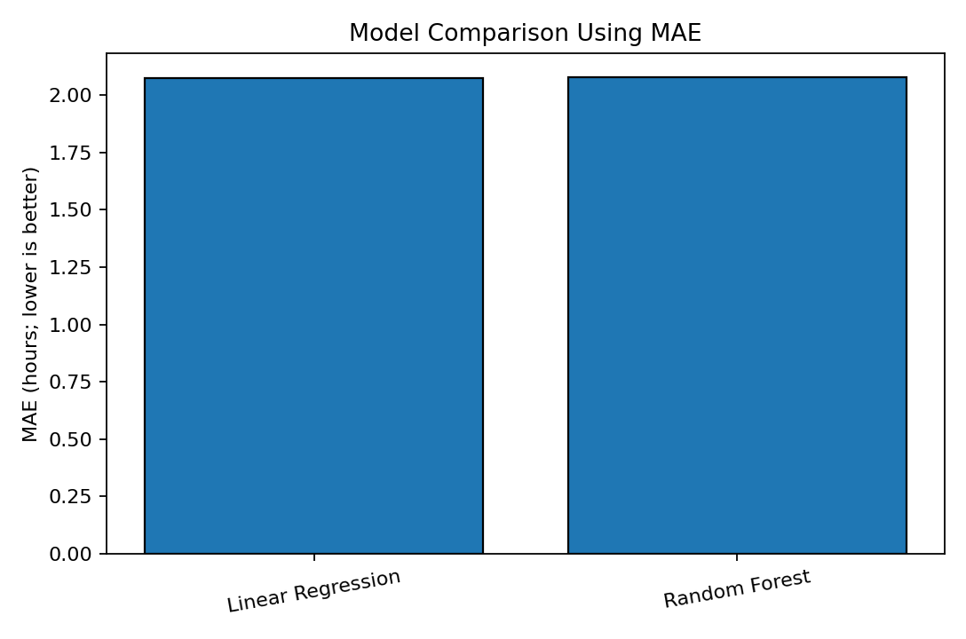
Figure 1. Model comparison by MAE.
This bar chart compares the average absolute prediction error for the two models. The lower bar indicates more accurate predictions in hours on the hold-out test set.
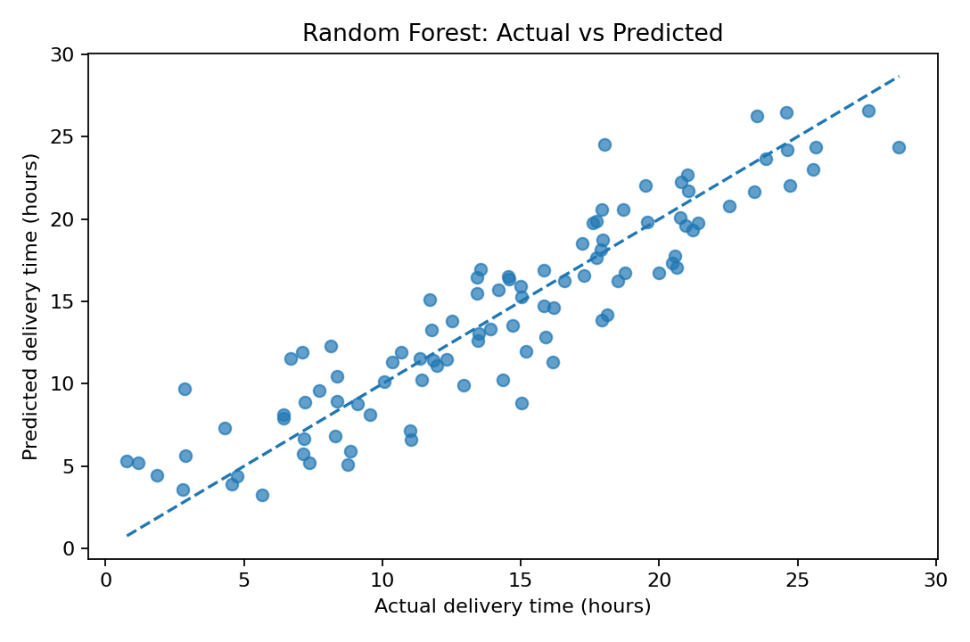
Figure 2. Actual versus predicted delivery time.
Points closer to the dashed diagonal represent predictions closer to actual delivery times. Large distances from the line indicate errors that may require investigation.
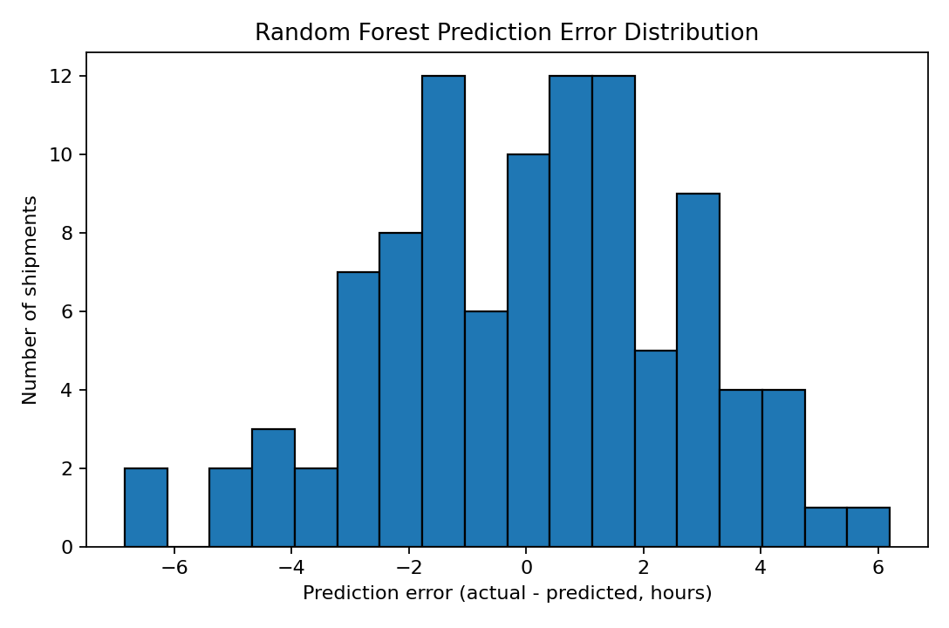
Figure 3. Prediction error distribution.
This histogram shows whether errors are centred around zero and whether large underestimates or overestimates occur. Operational use should pay particular attention to underestimates that could lead to missed delivery commitments.
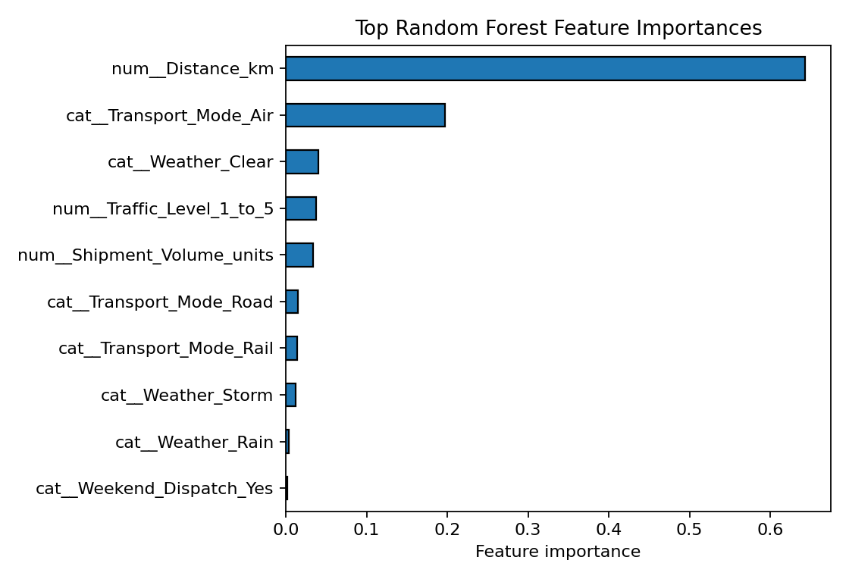
Figure 4. Random Forest feature importance.
This chart ranks the input features by their contribution to the Random Forest's split-based importance measure. Importance indicates model reliance, not causal effect.

7. Optimization Scenario
To demonstrate how predictions can support decisions, a hypothetical 400-km shipment with volume 30, clear weather, traffic level 2, and no weekend dispatch is scored under Road, Rail, and Air modes. These are scenario estimates from the model and do not include verified tariffs, capacity, emissions, transfer times, or real service constraints.
Transport mode | Predicted delivery time (hours)
Road | 10.58
Rail | 10.39
Air | 4.58
The scenario comparison illustrates a method, not an automatic decision. A practical optimizer should minimize a defined objective such as total cost subject to a delivery deadline, vehicle capacity, mode availability, and service constraints. Predictions can flag feasible options, while real prices and operational constraints determine the final choice.

8. Optimization Recommendations
- Use predictions at dispatch to flag shipments whose expected delivery time is close to or beyond the promised delivery window.
- Review high-risk shipments and consider earlier dispatch, alternate routes, or a different mode when operationally feasible.
- Combine predictions with verified transportation tariffs, capacity limits, handling time, and service-level requirements before choosing a mode.
- Monitor error metrics over time and investigate systematic underprediction, especially for weather and congestion conditions.
- Collect accurate historical data and retrain models periodically only after checking data quality and changes in operations.

9. Python Code Snippet
X = df.drop(columns=["Shipment_ID", "Delivery_Time_hours"])
y = df["Delivery_Time_hours"]
X_train, X_test, y_train, y_test = train_test_split(
X, y, test_size=0.20, random_state=24
)
model = Pipeline([
("preprocess", preprocess),
("model", RandomForestRegressor(
n_estimators=180, max_depth=12,
min_samples_leaf=2, random_state=24
))
])
model.fit(X_train, y_train)
pred = model.predict(X_test)
mae = mean_absolute_error(y_test, pred)
rmse = mean_squared_error(y_test, pred) ** 0.5
r2 = r2_score(y_test, pred)
The complete executable script is included separately as logistics_predictive_model.py.

10. Limitations
The dataset is synthetic, and the relationships were generated using assumed rules. The reported scores are therefore illustrative and are not evidence that the model will achieve the same performance on real shipments. Production deployment would require real historical records, a time-aware validation design if forecasting future periods, monitoring for drift, and checks for data leakage.

11. Conclusion
This project demonstrates the predictive modelling workflow: define a target, prepare data, compare a baseline model with a flexible model, evaluate with MAE/RMSE/R-squared, validate with cross-validation, and translate predictions into a constrained optimization discussion. Predictive estimates can improve planning when combined with verified operational costs, capacity, and service rules.

Appendix: Project Files
- logistics_predictive_dataset.csv — simulated dataset.
- logistics_predictive_model.py — full Python training and evaluation script.
- charts/ — model evaluation visualizations.
- README.md — repository overview and metrics.

